3D PRINTING ON salmovka
Primary School and Kindergarten Blansko
Salmova 17, Salmova 1940/17
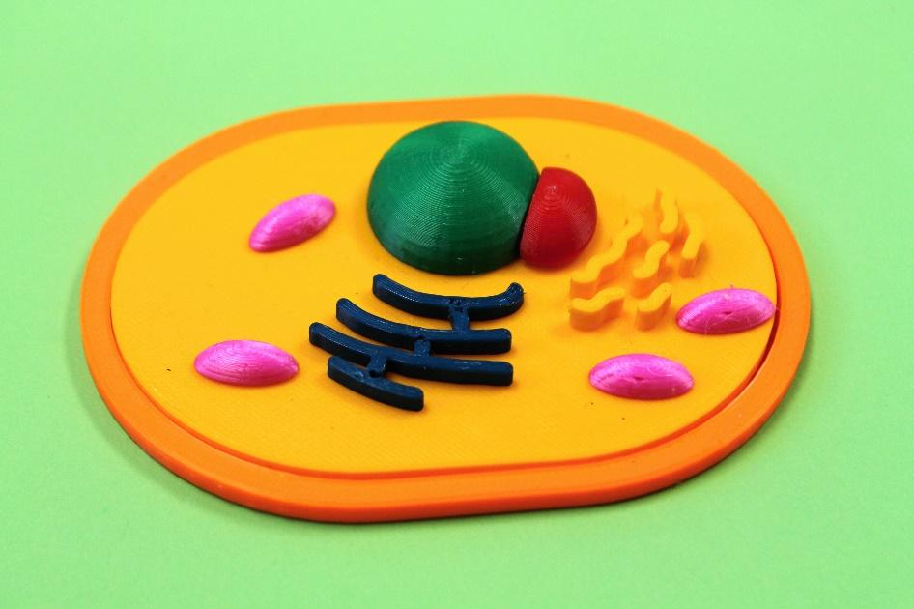

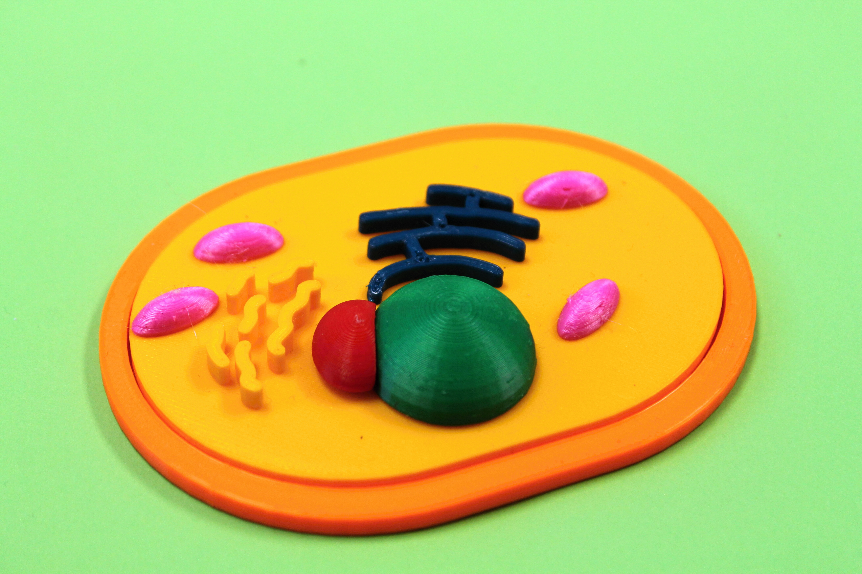
Contents:
Introduction 3
3D printing technology 4
FDM technology – fusion deposition modeling 4
Material for 3D printing 4
PLA 5
Financial budget 5
3D printing process 6
Creating a model of an animal cell 7
Cytoplasmic membrane 7
Cytoplasm and Golgi apparatus 10
Core 12
Nucleus 15
Mitochondria 19
Endoplasmic reticulum 22
Editing a 3D model for printing 23
Download the 3D model 23
Opening PrusaSlicer 23
Slicing 24
G-code export 24

Introduction
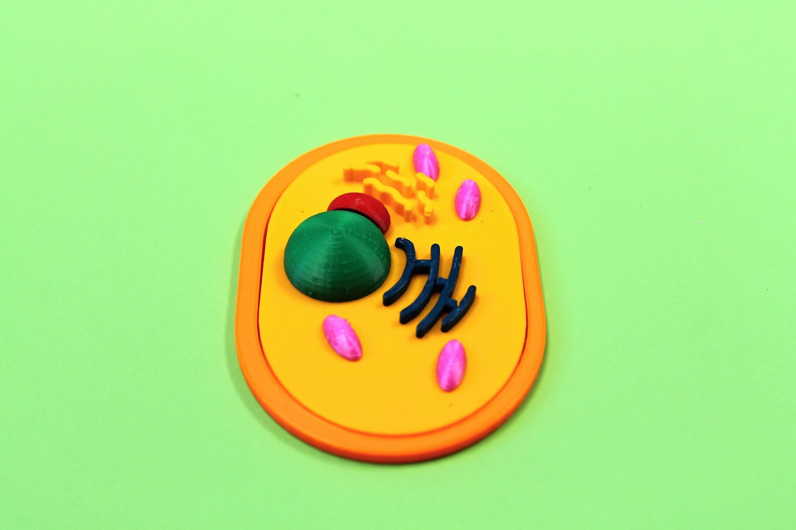
3D printing can be used to create a wide range of models - prints. In this guide, we will focus on 3D printing teaching aids, more specifically the creation of an animal cell

Our animal cell will be part of interesting biology lessons. Where the students will be able to assemble the cell individually and independently and thereby fix the necessary curriculum.
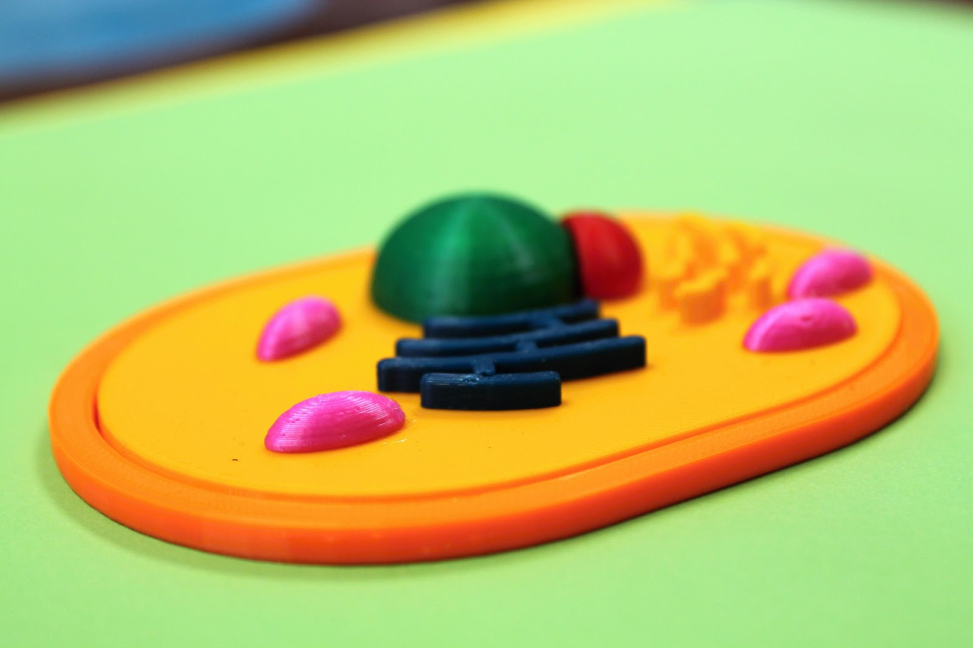

3D printing technology
3D printing is additive, or incremental manufacturing technology. Plastic materials are used for 3D printing at our school, but it is currently possible to print 3D models from other materials as well. Other possible materials include, e.g. ceramic, metal, concrete and others.

FDM technology – fusion deposition modeling
At the same time, this technology ranks among the most widely used. The principle of this technology is the melting of a plastic printing string and the gradual application of layers of molten plastic through a nozzle in the print head. Specifically, the object is created layer by layer by fusing a thin strip of plastic material. When printing more complex shapes with overhanging parts, so-called supports must be used. The supports are then broken out of the final print. It is possible to print fully functional plastic parts on a 3D printer, but it is necessary to take into account possible differences in mechanical properties. Various methods are used to remove the visibility of the layered structure on the surface of the print, such as polishing, sealing, sanding... The surface of the print can also be coated with various coatings.

Material for 3D printing
There is a wide range of materials for 3D printing. Each type of material has its own characteristic properties, which include, e.g. printing temperatures, mechanical specifications, usage suitability. Namely, they are: CPE, PET, PETG, ASA, ABS, PLA and many others.
In our case, PLA material is used.

PLA
Polylactic acid – this is also known as "eco-plastic", which is made from a natural material, specifically from starch. This is the reason why it is not very suitable to use PLA for prints that will be exposed to long-term outdoor use. Compared to other materials, it has a small thermal expansion. Therefore, the print does not curl and does not tend to peel off from the pad or crack. For that reason, it is also suitable for large prints. Prints from this type of filament are very hard. PLA is offered in the widest color spectrum. In terms of price, it is one of the cheapest materials. This type of filament is the most versatile.
Advantages of PLA
Easy printing, detailed printing of small models, trouble-free printing of large parts, hardness and rigidity, odorless printing, affordability, wide color spectrum.
Disadvantages of PLA
Fragility, low temperature resistance (loss of mechanical strength at above 60 °C, unsuitable for outdoor use.)
Application:
Prototypes, toys, figurines, jewelry...
Nozzle temperature: 190–220 °C Pad temperature: 40–60 °C

Financial budget
In our project, we work with the company “Průša printers”. More specifically, we use two types of printers – Original Prusa MINI and Original Prusa i3 MK3S.
Original Prusa i3 MK3S CZK 26,990
https://www.prusa3d.com/cs/produkt/3d-tiskarna-original-prusa-i3-mk3s-3/
Original Prusa MINI CZK 10,990
https://www.prusa3d.com/cs/produkt/original-prusa-mini-3/
Six different colors of filament were used to print our cell. The second option how we could achieve a color division is by coloring the individual parts.
Prusament PLA Prusa Orange 1kg CZK 699
Prusament PLA Pineapple Yellow 1kg CZK 699
Prusament PLA Royal Blue (Blend) 970g CZK 699
Prusament PLA Green 1kg CZK 699
Prusament PLA Ms. Pink (Blend) 970g CZK 699
Prusament PLA Lipstick Red 1kg CZK 699
https://www.prusa3d.com/cs/kategorie/prusament-pla/
When printing tiny but tall parts, we use Kores glue - to increase the stability of the print.

3D printing process
At the beginning, it is necessary to choose the object that we want to print on the 3D printer. After we choose the object then comes the execution itself.
First of all, it is necessary to provide a model of the subject. Here we have several options.
1. The first option is to create a model yourself, using software for 3D designs.
2. Another possibility is the creation of a 3D model using a 3D scanner.
3. The last option is to download a 3D model from the Internet.
After we obtain the 3D model it is transferred to the Slicer, where the model is cut into individual layers and the model is prepared for printing.
Now it is necessary to convert the model to g-code – instructions understandable for a 3D printer. It is necessary to have the g-code inserted on a portable medium (USB flash disc or SD card) or to have a computer connected to a 3D printer.
Preparation of the 3D printer itself - we turn on the 3D printer, then use the selected filament for printing and insert the portable medium.
Start 3D printing.

Creating a model of an animal cell
We use Tinkercad to create the model – this program is freely available on the Internet https://www.tinkercad.com/. When creating models, individual dimensions are given in millimeters. We will make the holes in the individual organelles 0.5 mm larger than the pins, due to the folding of the cell after it is printed.

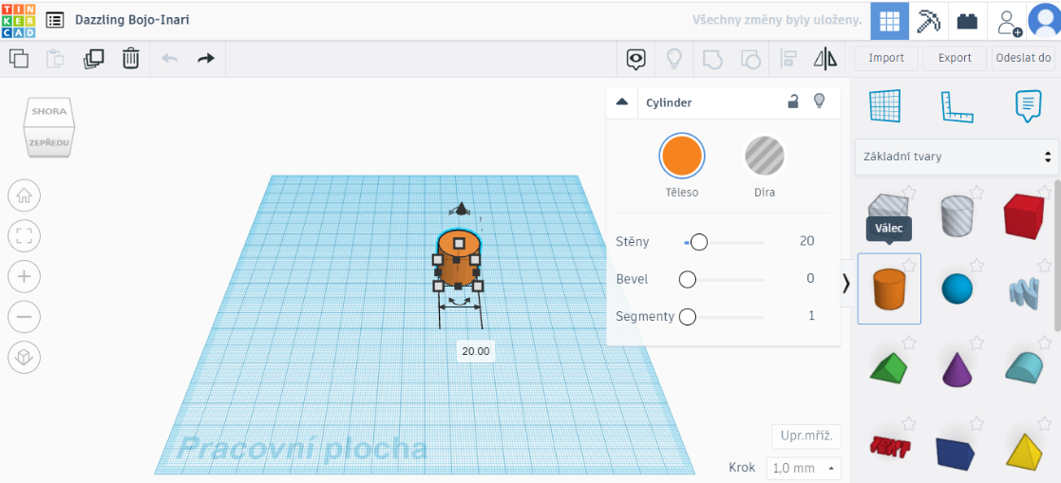
Cytoplasmic membrane

Insert the CYLINDER shape into the empty project

We set the selected dimensions: length: 70.5
width: 99
height: 4

We set the selected dimensions of the second cylinder -> for excavating the hole
length: 60.5
width: 90
height: 3.5

We will place the cylinders on top of each other

For the upper cylinder, we set the fill as HOLE.

We select both bodies and choose GROUP.

Completed
CYTOPLASMIC MEMBRANE

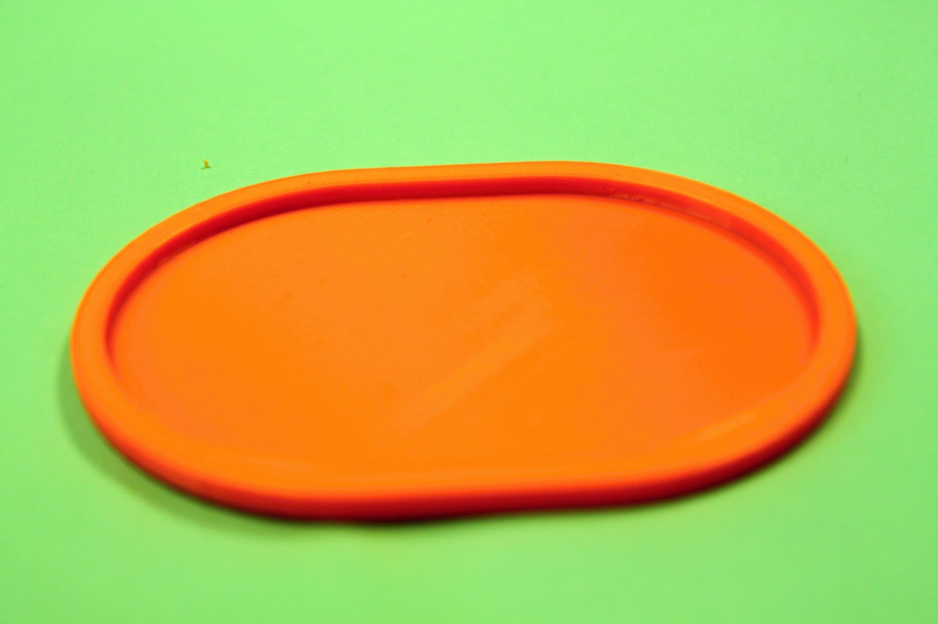

Cytoplasm and Golgi apparatus
We set the selected dimensions:
length: 60.5
width: 90
height: 3.5
Insert the CYLINDER shape into the empty project

On the CYTOPLASM, we will place holding PINS (cylinders) for other ORGANELES
1x core w: 16 x d: 16
4x mitochondria w: 2.5 x d: 2.5
1x core w: 2 x d: 2

Using the SCRIBBLE tool,
we will draw the Golgi apparatus.

Completed
CYTOPLASM with GOLGI APPARATUS

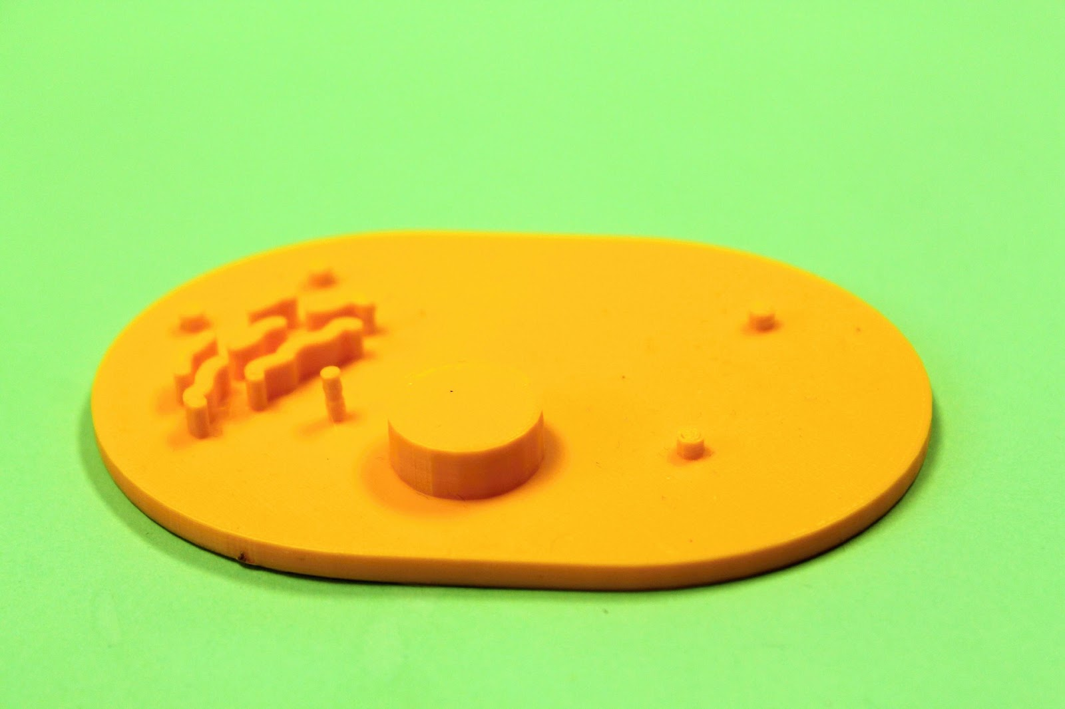

Core
Insert the SPHERE shape into the empty project

We set the selected dimensions: width: 25
length: 25
height: 25

We set the selected dimensions of the cube:
width: 30
length: 30
height: 12.5

We will create a HEMISPHERE from the sphere.
We insert a CUBE, set it as a HOLE and merge these two shapes together.

Now we will make a hole in the core for future folding of the cell.
To create the opening, we will use the CYLINDER
width: 16.5
length: 16.5
height: 10

Place the cylinder in the center of the hemisphere.
We set the cylinder as a hole.
We will group.

Completed CORE

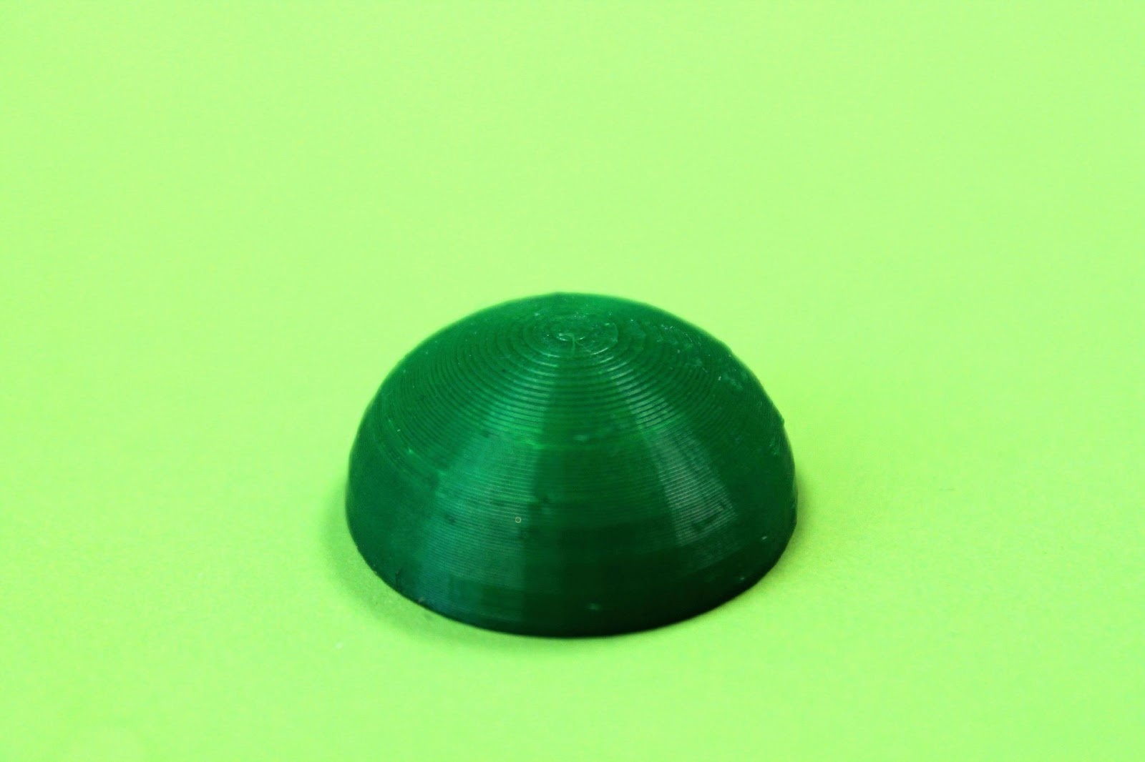

Nucleus
Insert the SPHERE shape into the empty project

We set the selected dimensions:
width: 20
length: 20
height: 20

We will create a HEMISPHERE from the sphere.
We insert a CUBE, set it as a HOLE and merge these two shapes together.

We set the selected dimensions of the cube:
width: 30
length: 30
height: 10

Now we shape the core according to the shape of the core.

For a more realistic idea, we will recolor the core.

Core

Copy the NUCLEOLUS to the workspace next to the CORE

Nucleolus

Place the core next to the kernel.
Then we set the core as a HOLE.
We will GROUP these two bodies together.

Now we will create a hole in the nucleus for future folding of the cell.
To create the opening, we will use the CYLINDER
width: 2.5
length: 2.5
height: 7

Place the cylinder in the center of the nucleus.
We set the cylinder as a stick.
We will group.

Completed NUCLEUS
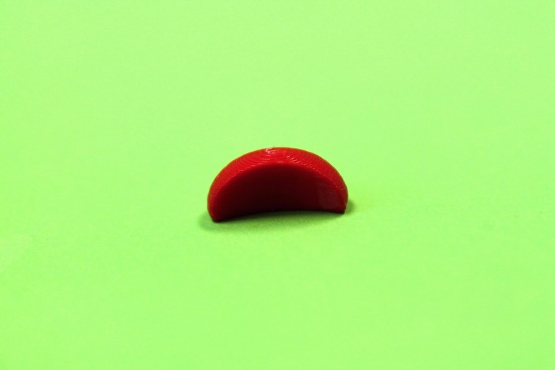
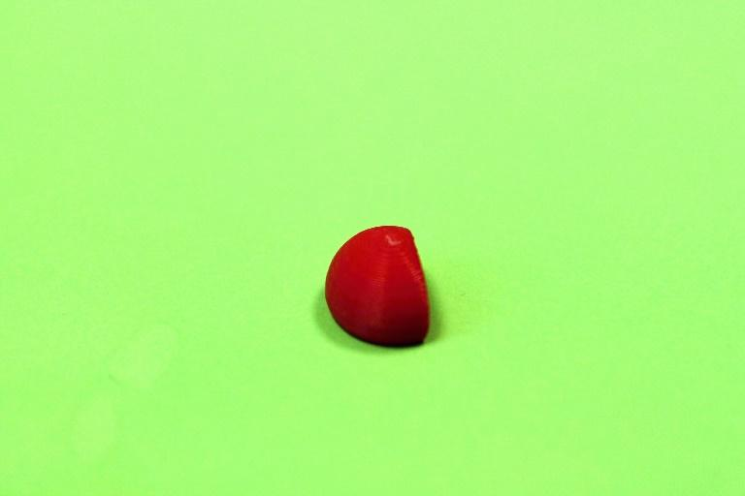

Mitochondria

Insert the HEMISPHERE shape into the empty project

We set the selected dimensions: width: 5
length: 14
height: 4

Now we will create an opening for future folding of the cell. And then we copy – a total of 4 mitochondria.
To create the opening, we will use the CYLINDER
width: 3
length: 3
height: 7

Place the cylinder in the center of the mitochondrion.
We set the cylinder as a hole.
We will group.

Completed MITOCHONDRIA

Endoplasmic reticulum
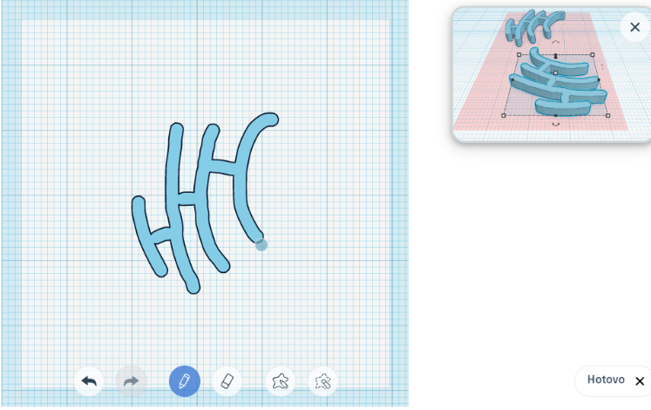
The endoplasmic reticulum was created using the Scribble tool

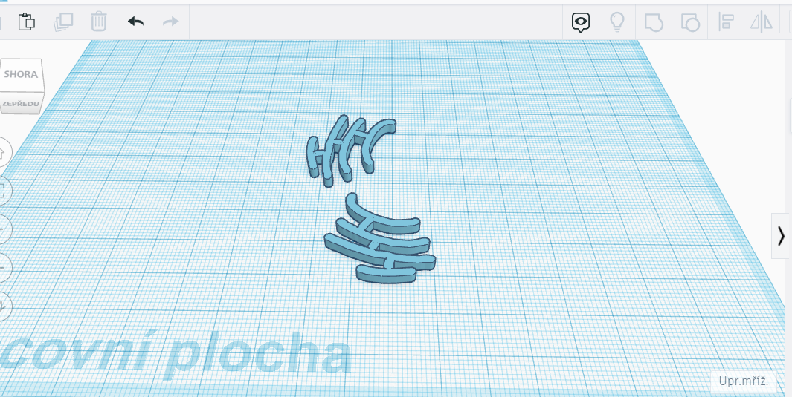

Completed
ENDOPLASMIC RETICULUME

Editing a 3D model for printing
The following steps must be followed before printing:

Download the 3D model
EXPORT -> PRO 3D TISK ->. STL EXPORT -> FOR 3D PRINTING ->. STL

Opening PrusaSlicer
When opening the Prusa Slicer APPLICATION, we choose the type of printer we will work with.
.

Slicing
Insert the downloaded file into the prepared program
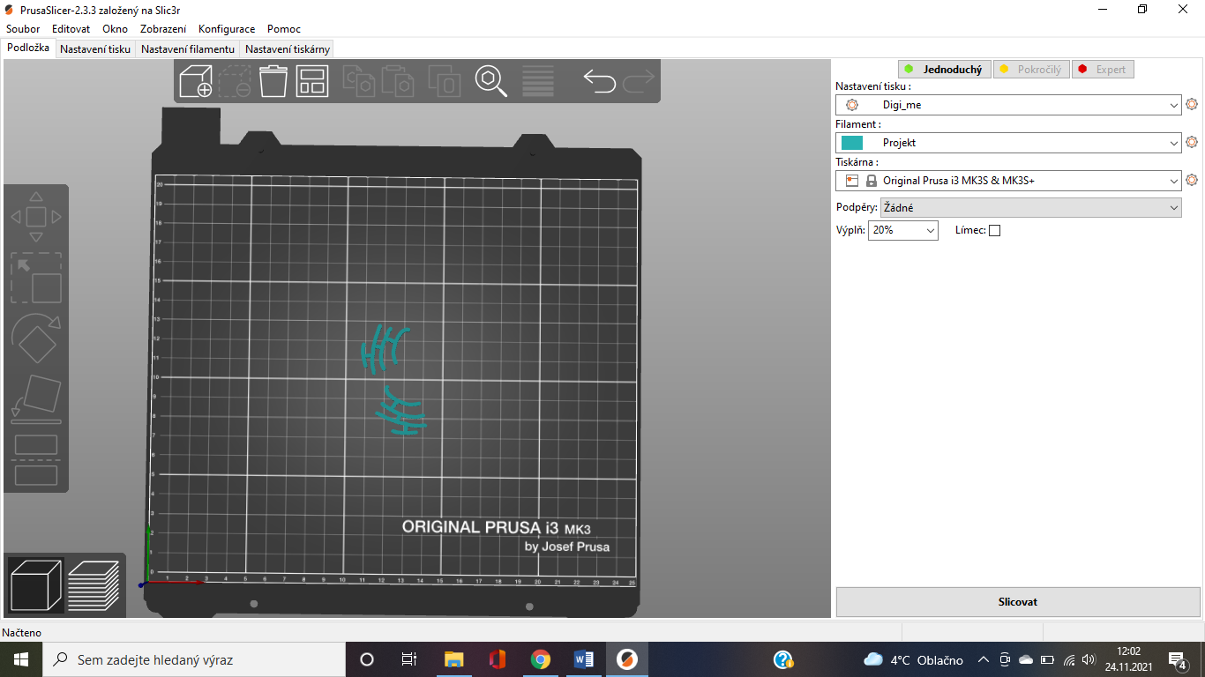

We will make any possible adjustments.
We set the filling density.

Now we choose Slice

G-code export

We save the G-code on a portable medium – flash drive x SD card
And we can print

